Name :Asala Ehab

ID:20201020

In the main fun first I generate the population then

I make for loop that will iterate with the number of generations

Then I will calculate the fitness by the function violated_points_fitness(npop,pop):

Then I will calculate the Elitism(fitN, eleitizem_size) that will return the best value for the population to can save it for the new generation

Then I wil select two parent with the tournament selection that will select two parent

It will take the fitness and the tournament size and the population and return the selected parents

Then we will do arithmetic cross over for the parents

Then we will call the gaussian_mutate that will make the muatation depend on the pmute

If the random value that we generate is less than pmute we will do the muation otherwise we don’t

Then at each generation we will get the best fitness and get the average fitness

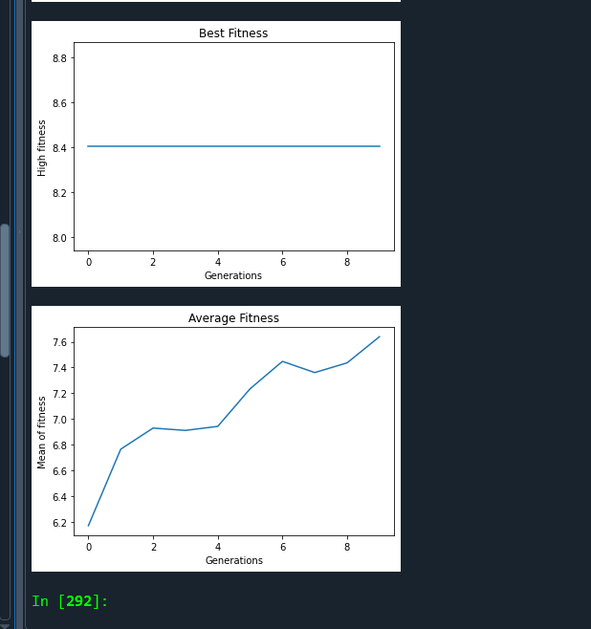

The previous was with elitism and it effect on the average fitness

And this without the elitism

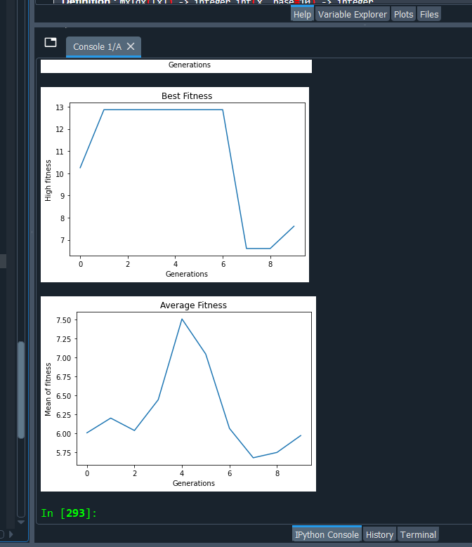

As we note that without eleitism it effect on the average fitness

Linear selection tends to maintain diversity in the population, while tournament selection tends to favor highly fit individuals.

So that the selection tournament will choose the higher fitness while the linear will make the probability for the other to be selected with the low fitness so it increase the diversity

Will the tournament always select the best fitness can these will keep the diversity always high

To produce children, arithmetic crossover entails averaging the corresponding genes of the parents. On the other hand, one-point crossover entails choosing a chance crossing site in the chromosomes of the parents and exchanging the genetic material beyond that point.

appropriate mutation operators for various input representation types. Genetic algorithms using binary coding should use bitwise mutation, whereas those with real coding should use gaussian mutation. For each operator, the effect of the mutation on the output solution varies.

Assiment three screenshot

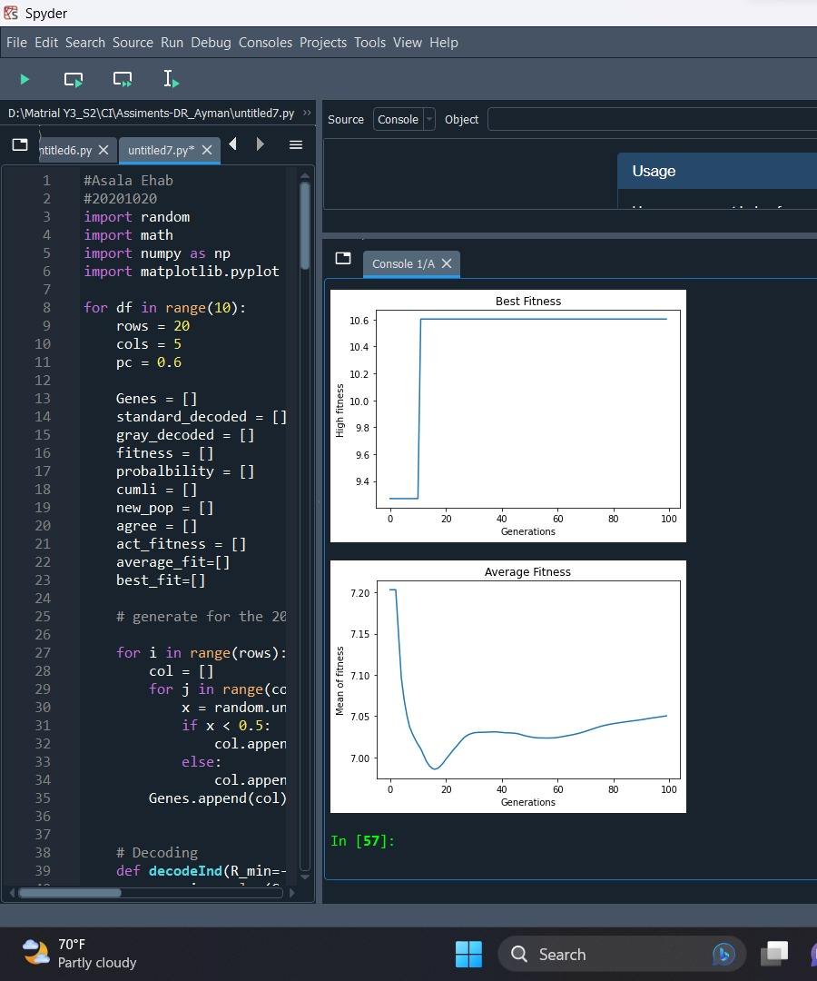

Assiment 3 screen shot

